**Employee Management System SQL Exercises**

**Creating Table**

-- Create Departments table

CREATE TABLE Departments (

DepartmentID INT PRIMARY KEY,

DepartmentName VARCHAR(100)

);

-- Create Employees table

CREATE TABLE Employees (

EmployeeID INT PRIMARY KEY,

FirstName VARCHAR(50),

LastName VARCHAR(50),

DepartmentID INT FOREIGN KEY REFERENCES Departments(DepartmentID),

Salary DECIMAL(10,2),

JoinDate DATE

);

**Inserting Table**

-- Insert sample data into Departments

INSERT INTO Departments (DepartmentID, DepartmentName) VALUES

(1, 'HR'),

(2, 'Finance'),

(3, 'IT'),

(4, 'Marketing');

-- Insert sample data into Employees

INSERT INTO Employees (EmployeeID, FirstName, LastName, DepartmentID, Salary, JoinDate) VALUES

(1, 'John', 'Doe', 1, 5000.00, '2020-01-15'),

(2, 'Jane', 'Smith', 2, 6000.00, '2019-03-22'),

(3, 'Michael', 'Johnson', 3, 7000.00, '2018-07-30'),

(4, 'Emily', 'Davis', 4, 5500.00, '2021-11-05');

**Exercise 1: Create a Stored Procedure**

Goal: Create a stored procedure to retrieve employee details by department.

Steps:

1. Define the stored procedure with a parameter for DepartmentID.

2. Write the SQL query to select employee details based on the DepartmentID.

3. Create a stored procedure named `sp_InsertEmployee` with the following code:

CREATE PROCEDURE sp_InsertEmployee

@FirstName VARCHAR(50),

@LastName VARCHAR(50),

@DepartmentID INT,

@Salary DECIMAL(10,2),

@JoinDate DATE

AS

BEGIN

INSERT INTO Employees (FirstName, LastName, DepartmentID, Salary, JoinDate)

VALUES (@FirstName, @LastName, @DepartmentID, @Salary, @JoinDate);

END

CREATE PROCEDURE sp_InsertEmployee

@FirstName VARCHAR(50),

@LastName VARCHAR(50),

@DepartmentID INT,

@Salary DECIMAL(10,2),

@JoinDate DATE

AS

BEGIN

INSERT INTO Employees (FirstName, LastName, DepartmentID, Salary, JoinDate)

VALUES (@FirstName, @LastName, @DepartmentID, @Salary, @JoinDate);

END;

CREATE PROCEDURE sp_GetEmployeesByDepartment

@DepartmentID INT

AS

BEGIN

SELECT

E.EmployeeID,

E.FirstName,

E.LastName,

D.DepartmentName,

E.Salary,

E.JoinDate

FROM Employees E

INNER JOIN Departments D ON E.DepartmentID = D.DepartmentID

WHERE E.DepartmentID = @DepartmentID;

END;

**Exercise 5: Return Data from a Stored Procedure**

Goal: Create a stored procedure that returns the total number of employees in a

department.

Steps:

1. Define the stored procedure with a parameter for DepartmentID.

2. Write the SQL query to count the number of employees in the specified department.

3. Save the stored procedure by executing the Stored procedure content

CREATE PROCEDURE sp_CountEmployeesByDepartment

@DepartmentID INT

AS

BEGIN

SELECT

D.DepartmentName,

COUNT(E.EmployeeID) AS TotalEmployees

FROM Departments D

LEFT JOIN Employees E ON D.DepartmentID = E.DepartmentID

WHERE D.DepartmentID = @DepartmentID

GROUP BY D.DepartmentName;

END;

**exercise 4: Execute a Stored Procedure**

Goal: Execute the stored procedure to retrieve employee details for a specific department.

Steps:

1. Write the SQL command to execute the stored procedure with a DepartmentID

parameter.

2. Execute the command and review the results.

EXEC sp_GetEmployeesByDepartment @DepartmentID = 2;

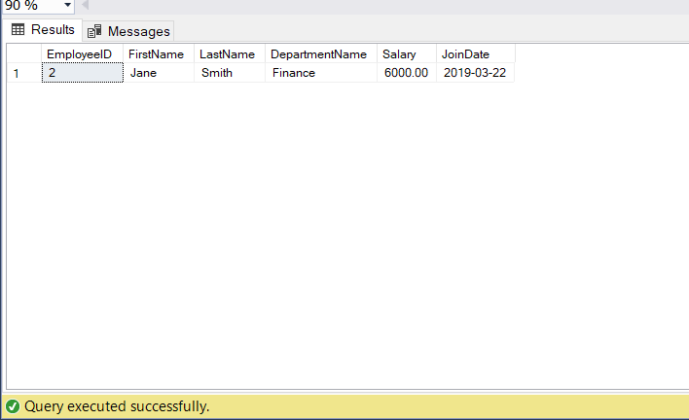

EXEC sp_CountEmployeesByDepartment @DepartmentID = 2;

